

ASUMBI GIRLS’ 2025 PREDICTION
CONFIDENTIAL KCSE EXAM
233/1
CHEMISTRY
PAPER 1
TIME: 2 HOURS

NAME………………………………………………………………………………
SCHOOL……………………………………………… SIGN………………………..
INDEX NO……………………………………………. ADM NO………………

(Kenya Certificate of Secondary Education)

INSTRUCTIONS TO CANDIDATES:
(a)Write your name, class and admission number in the spaces provided above.
(b)Answer ALL the questions in the spaces provided in the question paper
(c) KNEC Mathematical tables and electronic calculators may be used for calculations
(d) All working MUST be clearly shown where necessary
(e) Candidates should check the question paper to ascertain that all the pages are printed as indicated and that no questions are missing
(f) Candidates should answer the questions in English

FOR EXAMINER’S USE ONLY
Question | Maximum score | Candidate’s score
1-29 | 80

1. An element Y has the electronic configuration 2.8.5
- Identify its period (1mk)
………………………………………………………………………………………………

- Write a formula of the most stable anion formed when Y ionizes. (1mk)
………………………………………………………………………………………………

c) Explain the differences between the atomic radius of element Y and its ionic radius. (2mks)
………………………………………………………………………………………………
………………………………………………………………………………………………
………………………………………………………………………………………………

2. The table below shows tests carried out on a sample of water and the results obtained.
 | Test | Results
I | Addition of sodium hydroxide solution | White precipitate which dissolves in excess
II | Addition of excess aqueous ammonia | Colourless solution obtained
III | Addition of dilute hydrochloric acid and  barium chloride | White precipitate

- Identify the anion present in the water. (1mark)
………………………………………………………………………………………………
- Write an ionic equation for the reaction in III. (1mark)
………………………………………………………………………………………………

Solution | PH - VALUES
K  L  M | 1.5  7.0  14.0
3. Solutions can be classified as acids bases or neutral. The table below shows solutions and their pH values.

- Select any pair that would react to form a solution of pH 7. (1mark)
………………………………………………………………………………………………

- Identify two solutions that would react with aluminum hydroxide. Explain. (1marks)
………………………………………………………………………………………………
………………………………………………………………………………………………

4. a) State Graham’s Law of diffusion. (1mk)
………………………………………………………………………………………………
………………………………………………………………………………………………

b) 60cm³ of oxygen gas diffused through a porous partition in 50 seconds. How long would it take for 60cm³ of sulphur (IV) oxide gas to diffuse through the same partition under the same
conditions? ( S = 32.0, O = 16.0) (3 marks )
………………………………………………………………………………………………
………………………………………………………………………………………………
……………………………………………………………………………………………
………………………………………………………………………………………………
………………………………………………………………………………………………

5. Study the flow chart below and answer the questions that follow.
Metal oxide
Add excess NH_{3 (aq}
Add NH_{3 (aq}
Colourless solution Y
White precipitate X

- Identify the metal oxide. (1mk)
………………………………………………………………………………………………

- Write an ionic equation leading to the formation of the white precipitate X. (1mk)
………………………………………………………………………………………………
………………………………………………………………………………………………

- Give the formula of the ions responsible for the colourless solution Y. (1mk)
………………………………………………………………………………………………
………………………………………………………………………………………………

6. Two compounds of barium are barium sulfide and barium chloride.
(a) The hazard symbol shown in Figure below is on bottles containing barium metal.
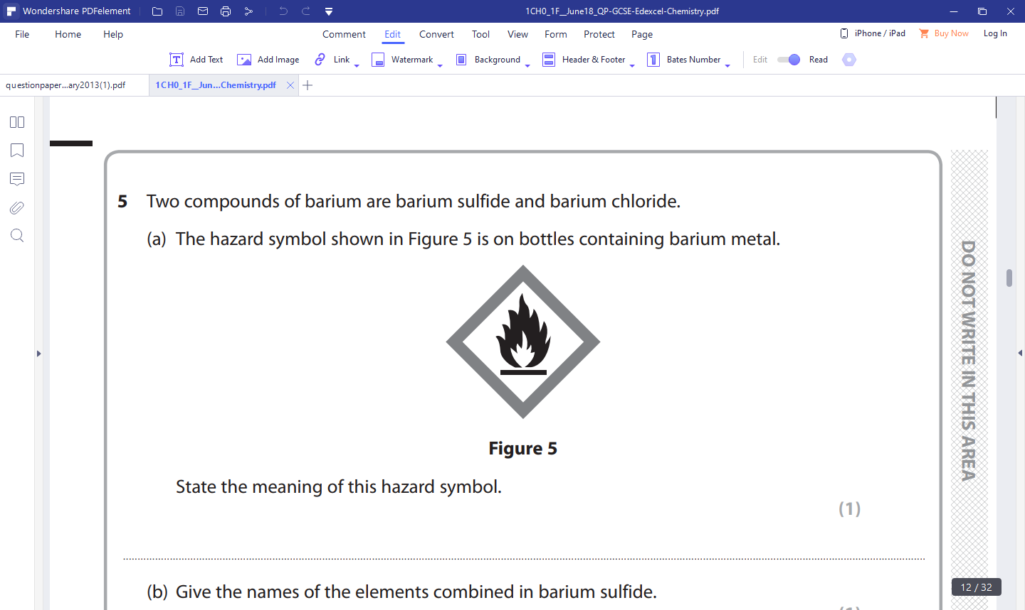
State the meaning of this hazard symbol. (1mk
………………………………………………………………………………………………
(b) Give the names of the elements combined in barium sulfide. (1mk)
………………………………………………………………………………………………
(c) Hydrogen sulphide gas is highly poisonous. Sate one safety precaution that should be taken
when handling hydrogen sulphide. (1mk)
………………………………………………………………………………………………
………………………………………………………………………………………………

7. Study the information in the table and answer questions that follow:
₇₁
R₂
³¹

₆₉
R₁
³¹
Isotope

Relative abundance % | 61.3 | 38.7

(a) Determine the number of neutrons of R₁ . (1mk)
………………………………………………………………………………………………
………………………………………………………………………………………………
………………………………………………………………………………………………

(b) Calculate the relative atomic mass of element R. (2mks)
………………………………………………………………………………………………
……………………………………………………………………………………………………………………………………………………………………………………………

8. a) Identify the type of bond formed compound below. (1mk)
H
H
O

b ) Using dots (•) and crosses (x) to represent electrons show bonding in magnesium oxide
(2mks)

9. Show the products formed when the following salts are heated by writing a balanced chemical equation. (2 marks)
Heat
(i) KNO_{3(s)}
Heat
(ii) (NH₄)₂ CO_{3(s)}

10. Explain why when one is stung by a bee application of a little solution of sodium
hydrogen carbonate helps to relieve the pain. (2 marks )
………………………………………………………………………………………………
………………………………………………………………………………………………
………………………………………………………………………………………………

11. The following table gives the melting point of oxides of the third period elements.
Study it and answer the questions that follow.
Formula of oxides | Na₂O | MgO | Al₂O₃ | S_{i}O₂ | P₄O₁₀ | SO₂
Melting point (⁰O) | 1190 | 3080 | 3050 | 1730 | 560 | -73

(a) Explain the large difference in the melting points of Na₂O and P₄O₁₀. (2 mark)
……………………………………………………………………………………………
………………………………………………………………………………………………
………………………………………………………………………………………………

(b) Write the equation for the reaction between Al₂O₃ with;
(i) NaOH (1 mark )
………………………………………………………………………………………………
(ii) HCl (1 mark )
………………………………………………………………………………………………………

12. A hydrocarbon slowly decolourlises bromine in presence of sunlight but does not decolourise
acidified potassium permanganate. Name and draw the structural formula of the fourth member of the series to which the hydrocarbon belongs. (2 marks )

13. Distinguish between ionization energy and electron affinity. (2mks)
………………………………………………………………………………………………
………………………………………………………………………………………………
………………………………………………………………………………………………
………………………………………………………………………………………………

14. The set-up below was used to prepare a carbon (IV) oxide gas.
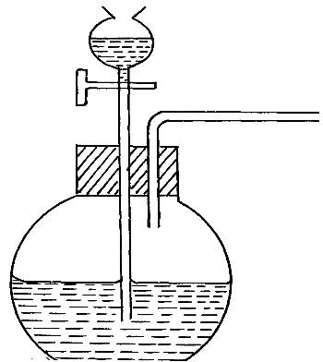
A
Calcium carbonate

(a) Give the name of substance A (1mk)
………………………………………………………………………………………………
(b) Complete the diagram to show how the dry gas can be collected. (2mks)
(c)Write the equation for the reaction (1mk)
………………………………………………………………………………………………
………………………………………………………………………………………………

15. Calculate the mass of sulphur which on complete combustion would yield 7dm³ of sulphur (IV) oxide measured at 182ºc and 722 mm Hg pressure. (0=16, S=32, molar gas volume = 24dm³ at r.t.p). (3 mks)
………………………………………………………………………………………………
………………………………………………………………………………………………
………………………………………………………………………………………………
………………………………………………………………………………………………

16. Form two students from Achiever’s secondary school reacted three elements as shown in the table below
Element | Reaction with Oxygen | Reaction with water
X | Formed acidic oxide | No reaction
Y | Formed basic oxide | Formed soluble hydroxide gave off hydrogen gas
Z | Formed acidic oxide | Dissolved to form an acidic solution
Which element (s) is likely to be: (3mks)
- Non-metal (s)
………………………………………………………………………………………………
- Metal (s)
………………………………………………………………………………………………
- Insoluble in water.
………………………………………………………………………………………………

17. A polymer has the following structure
CH₂ CH CH₂ CH CH₂ CH

CN CN CN
A sample of this polymer is found to have a molecular mass of 5194. Determine the number
of monomers on the polymer. ( H = 1.0, C = 12.0, N = 14.0 ) (2 marks )
………………………………………………………………………………………………
………………………………………………………………………………………………
………………………………………………………………………………………………
………………………………………………………………………………………………

18.a) State the likely products of the electrolysis of molten potassium chloride at the:-
(i) Cathode ……………………………………………………………………………….(½mk)

(ii) Anode ………………………………………………………………………………. (½mk)

b) Write the equations that occur at the anode and cathode. …….(2mks)
Anode………………………………………………………………………………………
Cathode…………………………………………………………………………………

19. Give two reasons why helium is used in weather balloons. (2mks)
………………………………………………………………………………………………
………………………………………………………………………………………………
………………………………………………………………………………………………

20. A Bunsen burner produces a yellow flame when airhole is close. Explain. (2mks)
………………………………………………………………………………………………
………………………………………………………………………………………………
………………………………………………………………………………………………

21. In an experiment, a boiling tube full of chlorine gas was inverted into a trough of water as shown below.
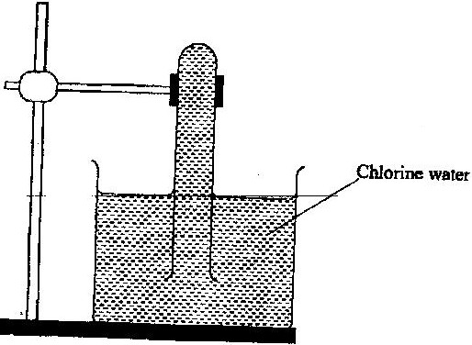
Sunlight
- State and explain the observations. (2mks)
………………………………………………………………………………………………
………………………………………………………………………………………………
………………………………………………………………………………………………

- If the experiment is repeated with tetrachloromethane instead of water.
i) State the observations made. (1mk)
………………………………………………………………………………………………
………………………………………………………………………………………………

ii) Explain your observations in b(i) above. (1mk)
……………………………………………………………………………………………
………………………………………………………………………………………………

23. Study the flow chart below and answer the questions that follow.
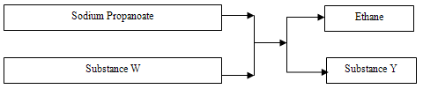
- Name substances
W ……………………………………………………………..….(½ mark)
Y …………………………………………………………….…..(½ mark)

- An organic compound K reacted with bromine to form 2,3 – dibromobutane. Draw the
structural formula of K. (1mks)

24. Starting with copper metal describe how a solid sample of copper (II) carbonate can be prepared. (3 marks )
………………………………………………………………………………………………
………………………………………………………………………………………………
………………………………………………………………………………………………
………………………………………………………………………………………………
………………………………………………………………………………………………

25. Study the information in the table below and answer the questions that follow. The letters do not represent the actual symbols of the elements.
Element | Electrical conductivity | Ductility | Action of water
A | Good | Good | No reaction
B | Good | Poor | No reaction
C | Good | Good | Reacts

Select the element which is
(a) Likely to be in group II of the periodic table. ( ½ mark )
………………………………………………………………………………………………

(b) Could be used to make electric cables. ( ½mark )
………………………………………………………………………………………………

(c ) Likely to be graphite. ( ½ mark )
………………………………………………………………………………………………

26. In an investigation, sulphur (IV) oxide gas was bubbled through acidified bromine water. This was followed by drops of barium nitrate solution.
(a) State the property of sulphur (IV) oxide under investigation. (½ mark)
………………………………………………………………………………………………
………………………………………………………………………………………………

(b) i) State the observation that were made on addition on sulphur (IV) oxide into the bromine water. (1mk)
………………………………………………………………………………………………
………………………………………………………………………………………………

ii) Explain the observation. (1mk)
………………………………………………………………………………………………
………………………………………………………………………………………………

27. Study the flow chart below and answer the questions that follow
O₂
Platinum
H₂O
Ammonia
Gas X
Nitrogen (II) oxide

Nitrogen (IV) oxide
G & J
(aq)
- Identify gas X (1mk)
………………………………………………………………………………………………

- Write an equation for the reaction between ammonia and gas X (1mk)
………………………………………………………………………………………………
………………………………………………………………………………………………

- Write an equation to show the formation of G and J (1mk)
………………………………………………………………………………………………
………………………………………………………………………………………………

28. (a) Define pollution. (1 mark )
………………………………………………………………………………………………
………………………………………………………………………………………………

(b) Mention one pollutant that is
(i) A Particle ( ½ mark )
………………………………………………………………………………………………

(ii) Gaseous ( ½ mark )
………………………………………………………………………………………………

29. Hydrogen gas was burnt in air to form a colourless liquid.
a) Describe a chemical test to identify the colourless liquid. (2mk)
………………………………………………………………………………………………
………………………………………………………………………………………………
………………………………………………………………………………………………
………………………………………………………………………………………………

b) State how the purity of the colourless liquid can be determined. (1mk)
……………………………………………………………………………………………………………………………………………………………………………………………
………………………………………………………………………………………………

THIS IS THE LAST PRINTED PAGE

